User guide

**HOME-Main menu :** 

The munu bar is always visible on top of all pages of the website, so the users can easily choose the page they want to see or return to the homepage by clicking on the name of the elements in the menu which they are interested in. Besides, when on the homepage, the users can click on the 2 arrows on both sides to see 4 pictures of 4 birdges in the top 1 of all type and if they like which one, they can click the See more button to see more information about it.

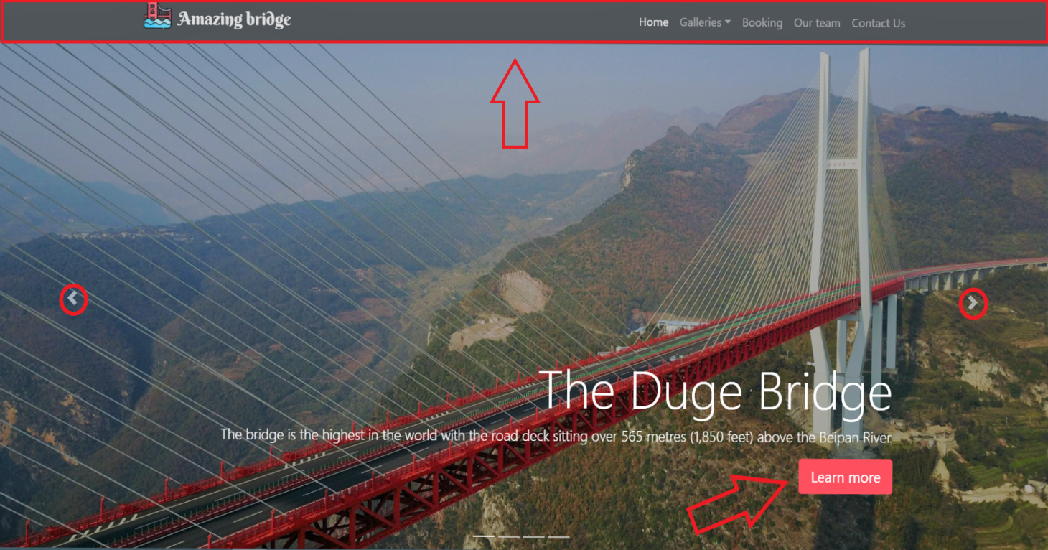

**Galleries:**

In this section, the users will see 4 bridges in the top 4 of each type. Firstly they can choose an image in [1] to see a clearer picture will appear in [2] or if they want to see full screen then click a icon in [3]. Then, for more information as well as the bridges’s location or feedback, the users can choose buttons in [4].

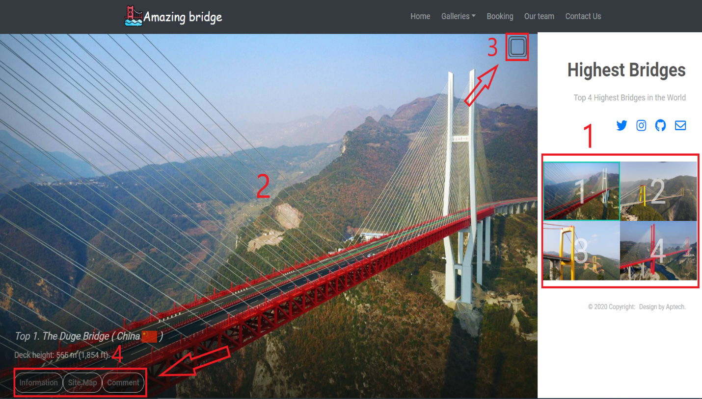

Fullscreen picture, click icon to back.

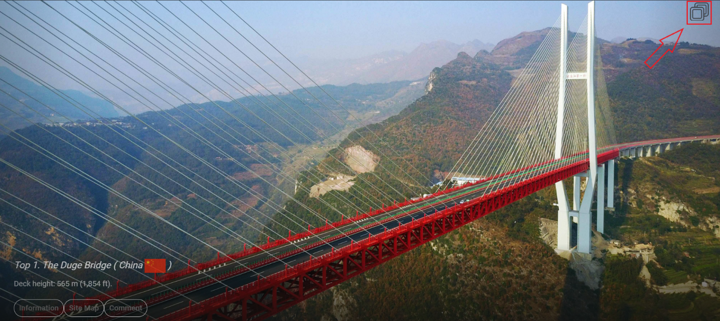The information of the bridges

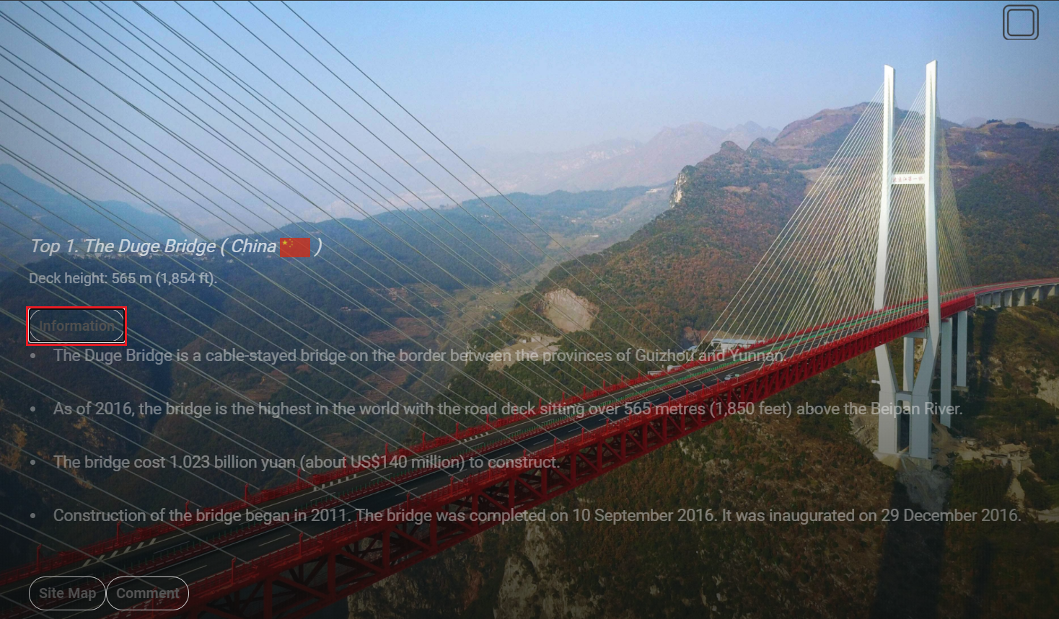

We provided you exactly Location about Bridge.

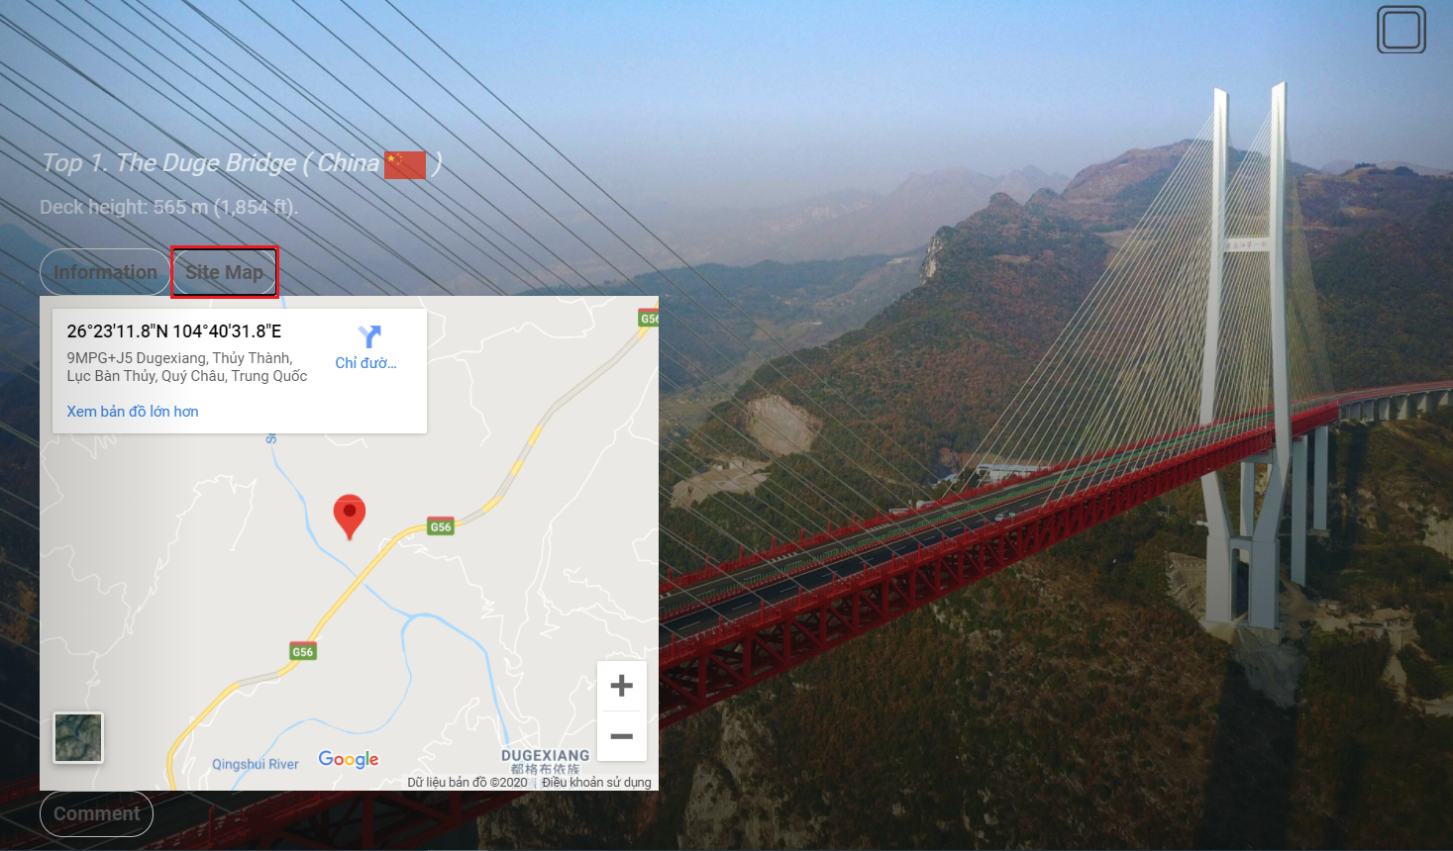

You can comment your idea about bridge in Feedback form

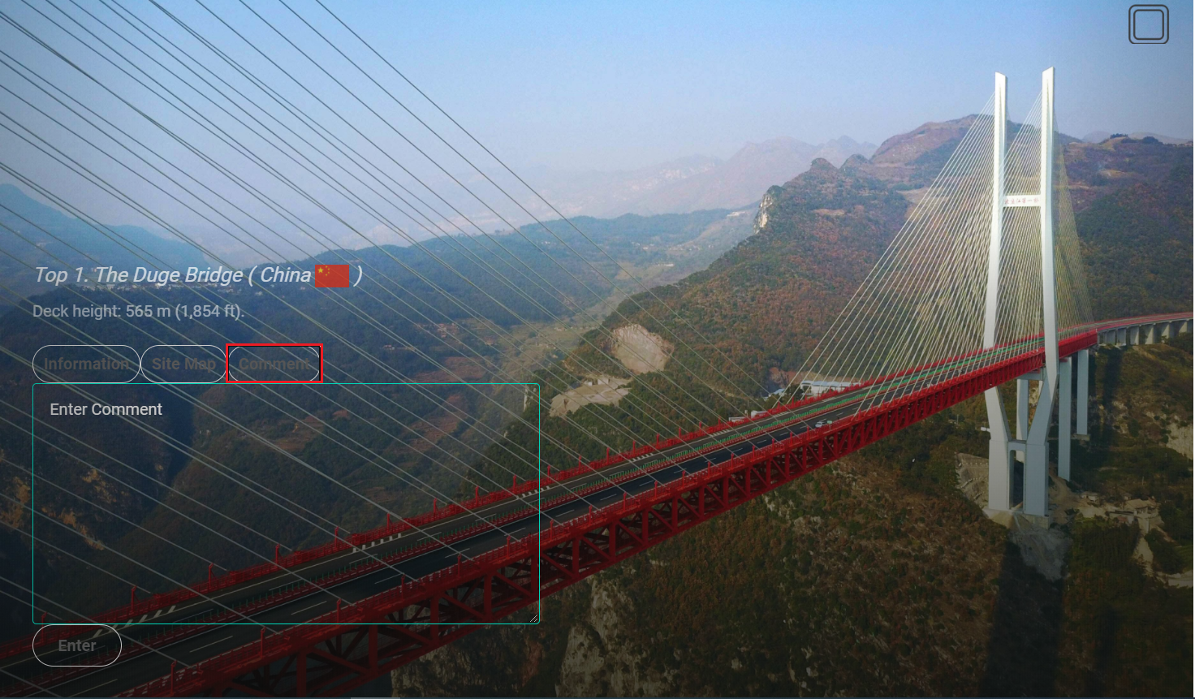

**Booking Section:**

When you click tab Booking on the menu bar, this from will be appear. After, the users completes the information, then they click the Book Now button, the information will sent to us.

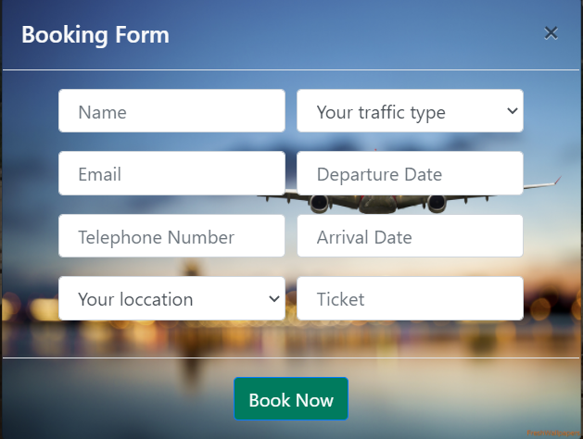**Team Menu :**

Next is Our team, the users can send email or call us by the way click on button when they move the mouse on the picture of one of us.

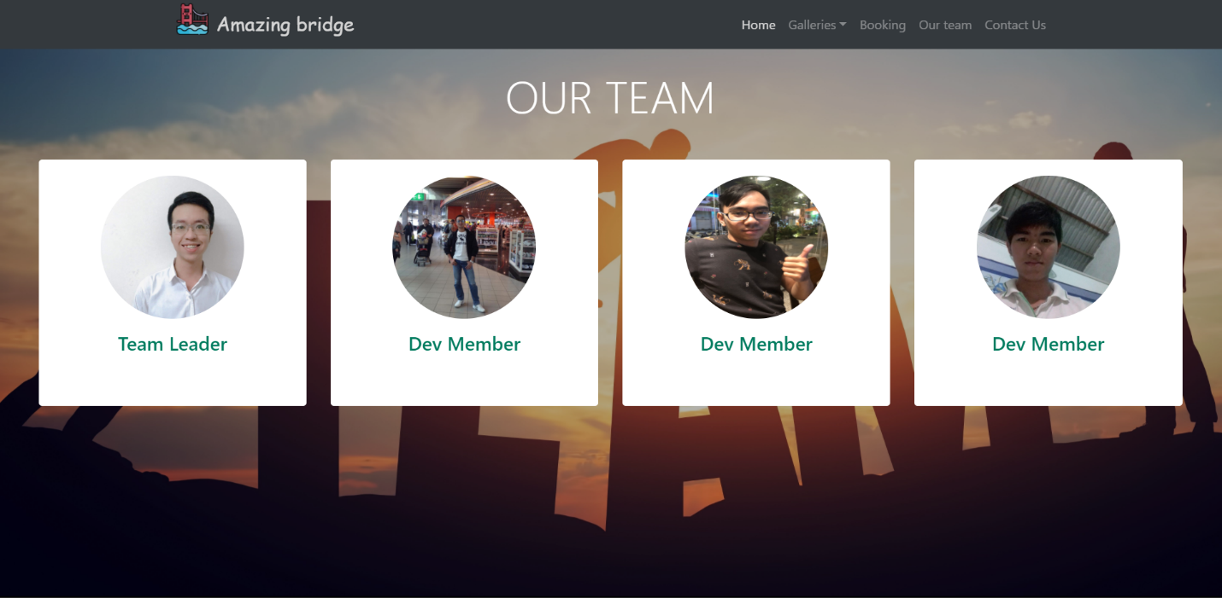

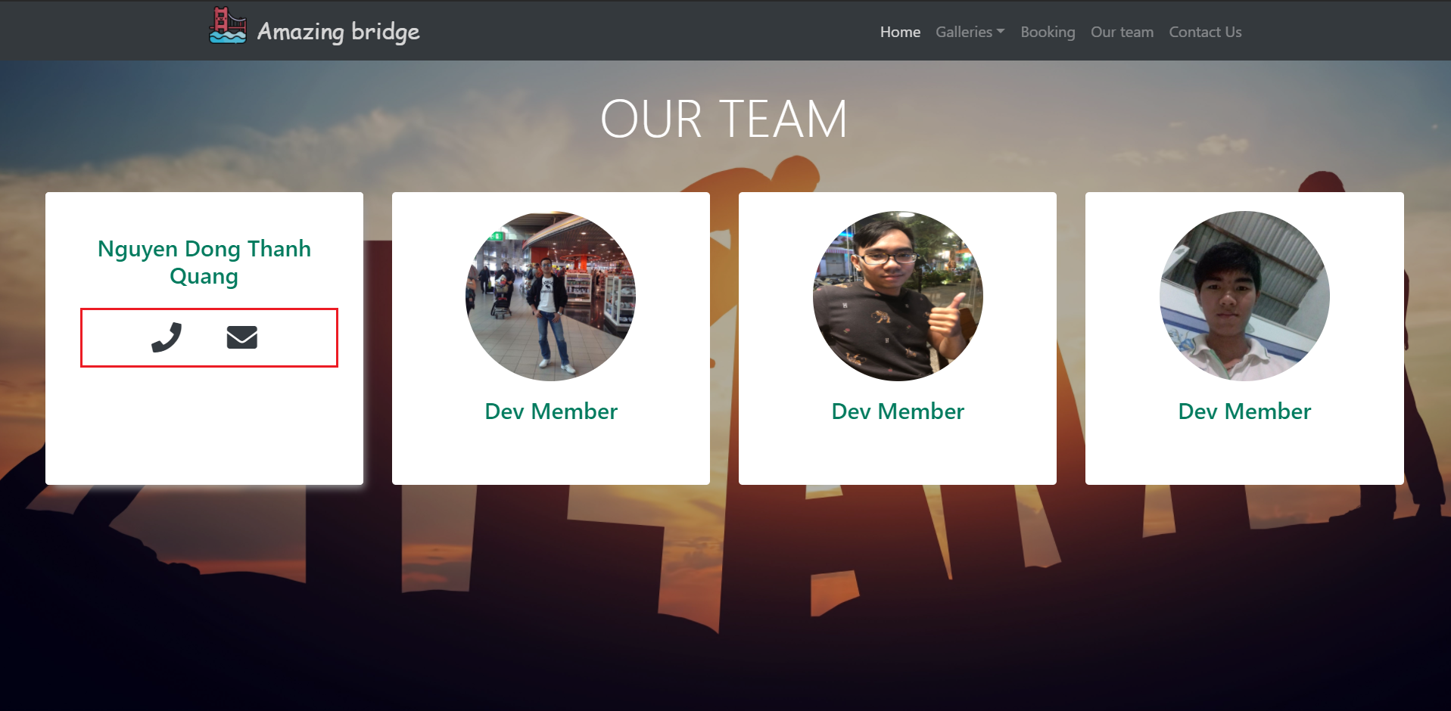

**Contact Us Menu :**

In the end, the users can contact us via complete the form, please don’t fill out any fields then click on Send Message. We will reply soon. We also provided our location via Google Map, from that they can know where we are.

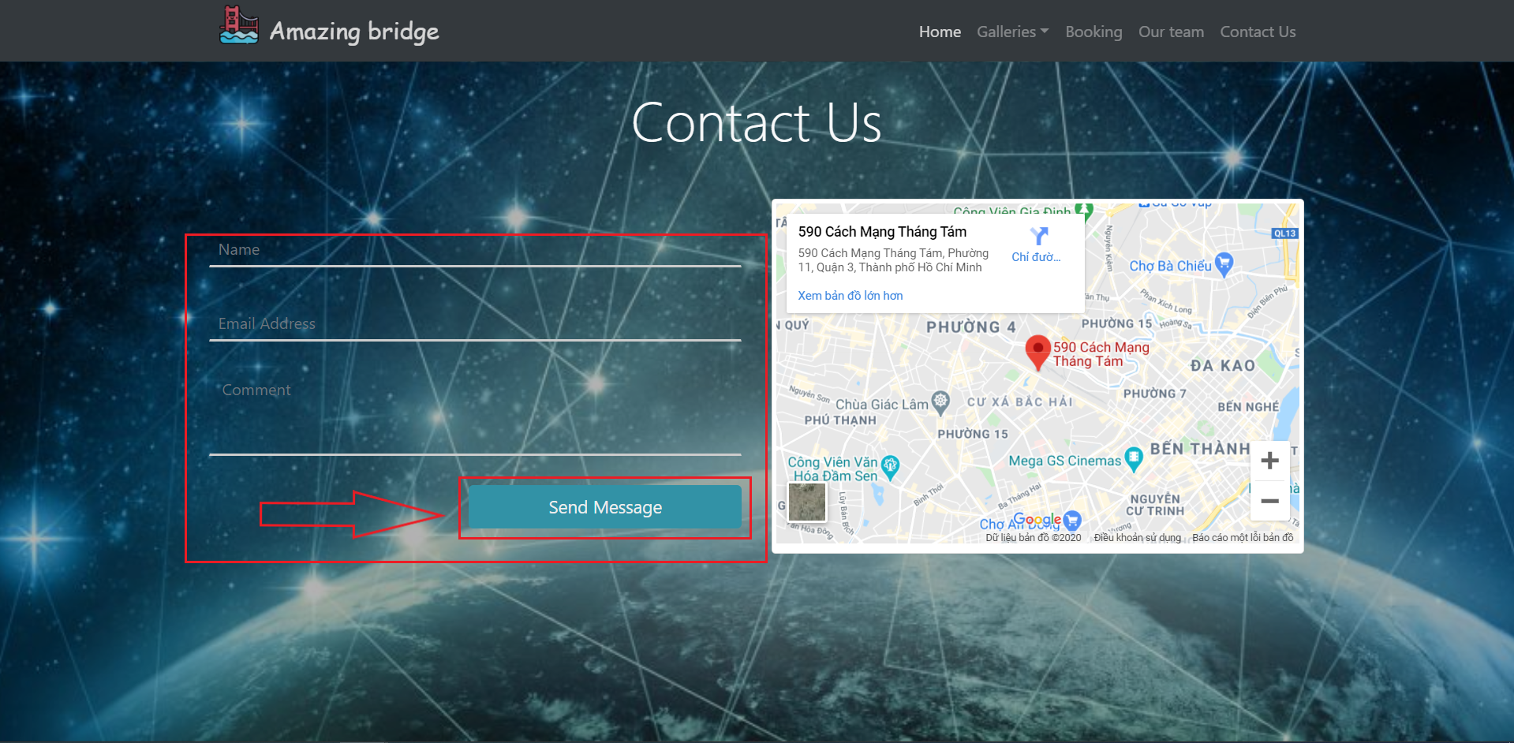

**THANK FOR WATCHING**